SETTING 11

Some more modifications / replacements

Setting 11A 11Aa

As stated by Børge Schäffer, during 4 øre print 9 the cliché A65 had been replaced by
a new one. But also on position A75 a replacement had been done during 4 øre print 9!
The following pair shows 4ø9a positions A75-A76, with the old cliché in A75.
Please note the frame-flaw in the SW-corner. The single stamps shows 4ø9b A75 with
the new (and sharp) cliché, as described by Lasse Nielsen, p.1348.

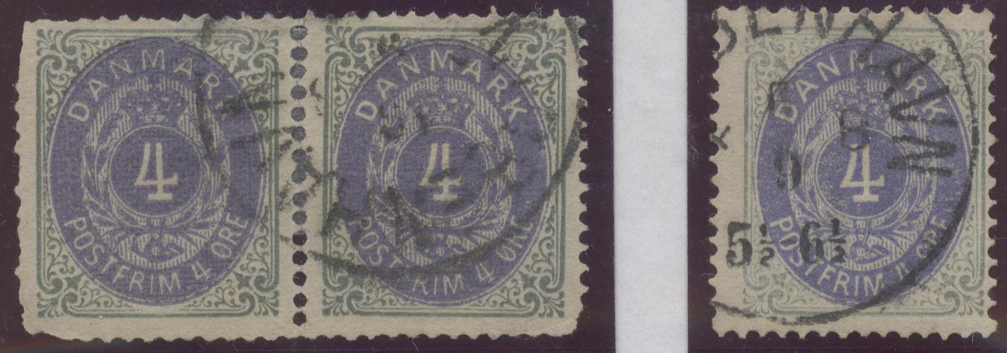

Setting 11B1 11B2

The cliché on position B45, which has been described by Lasse Nielsen as 11.145,
was used before in setting 6 on position B74 (6.174).
As setting 11 in the beginning was made of 200 new clichés, there is the only conclusion,
that this cliché (11.145) also had been substituted and was in use only from 4 øre print 10!
The following stamps are 4ø7 B74 and 4ø10 B45:

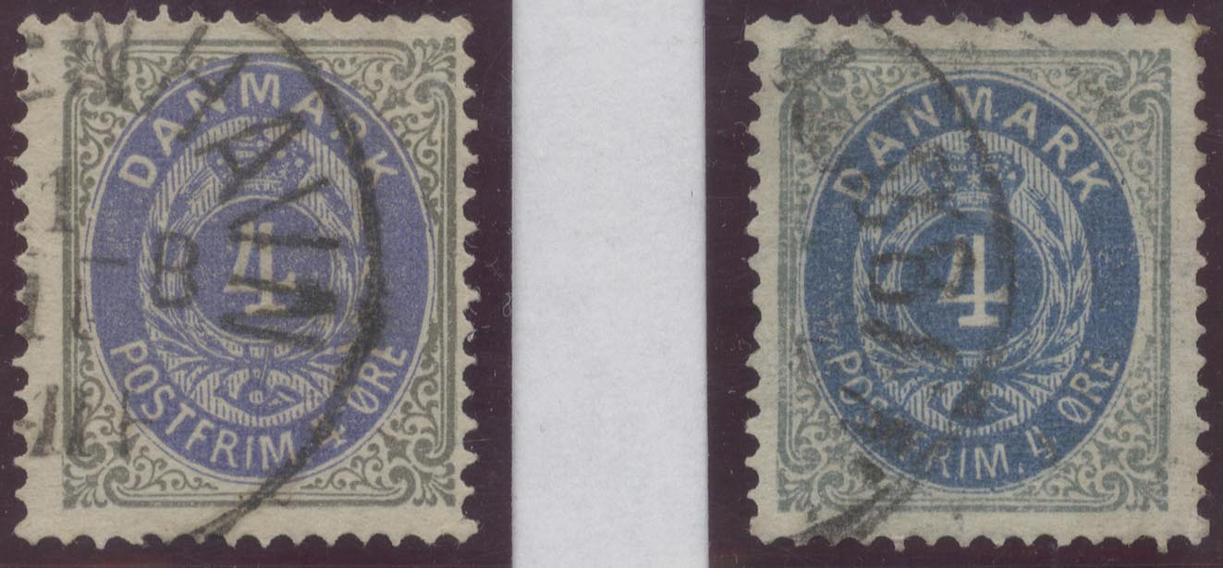

It is very strange, that so many modifications especially in the fifth row
of this setting occurred (A65, A75, B45) !?

Furthermore in the bottom row not only positions B91, B93 and B98 were replaced,
but also B99 and B100. As this was noted already by Børge Schäffer in his collection,
it is a bit astonishing, that Lasse Nielsen did not mention this fact in his book.
The stamps shown below are 8ø10 B100 (setting 11B1) and 4ø8 B99 (setting 11B2),
the pair is 12ø5 B99-100 with new clichés (copy from the ark of the post-museum).

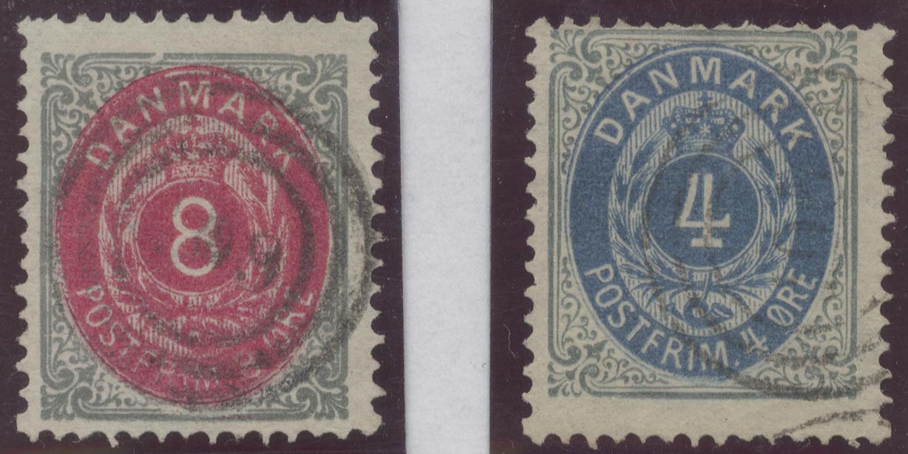

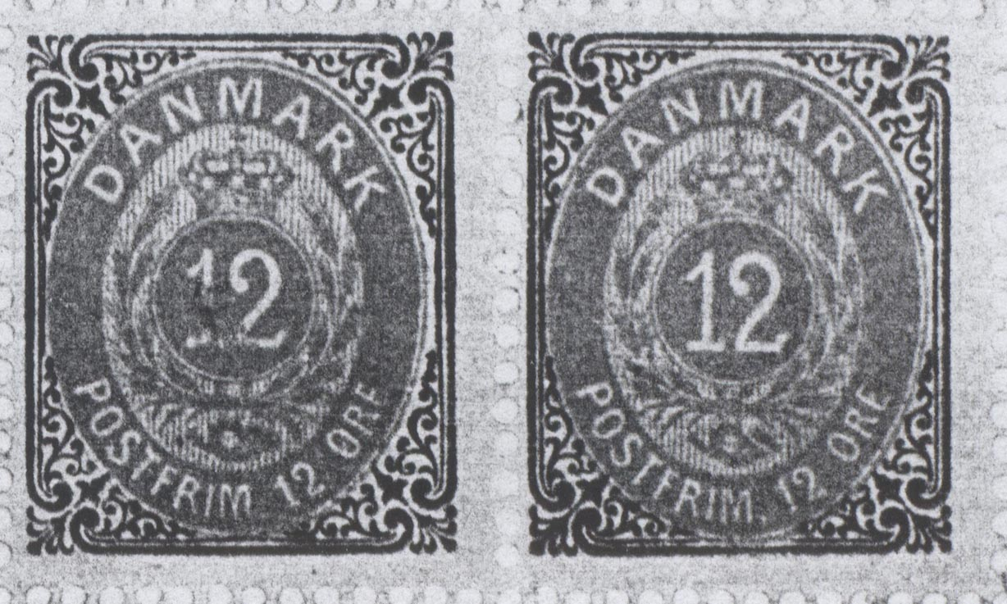

Bernd Stein
21.12.2003

